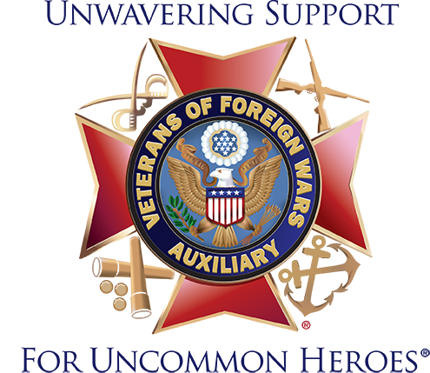
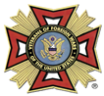
DEPARTMENT OF PENNSYLVANIA VFW AND AUXILIARY
ANNUAL CONVENTION
June 12 -15, 2024

ROOM RESERVATION FORM

DEADLINE FOR RESERVATIONS: MAY 24, 2024

SHERATON HARRISBURG HERSHEY HOTEL
4650 LINDLE ROAD
HARRISBURG, PA 17111
717-564-5511

ALL RESERVATIONS MUST BE MADE DIRECTLY WITH THE HOTEL BY PHONE OR USING THE LINK BELOW.

Room Rate: $ 139.00 plus 11% tax per night = $154.29

In order to receive the reduced group rate, overnight reservations must be received no later than May 24, 2024.

If calling for reservations, 717-564-5511 and you must use the code of “V5W”

If you choose to make your reservations on line, here is the link:
Booking Link: Book your group rate for VFW Annual Conference 2024
www.marriott.com/event-reservations/reservation-link.mi?id=1696612736156&key=GRP&app=resvlink

